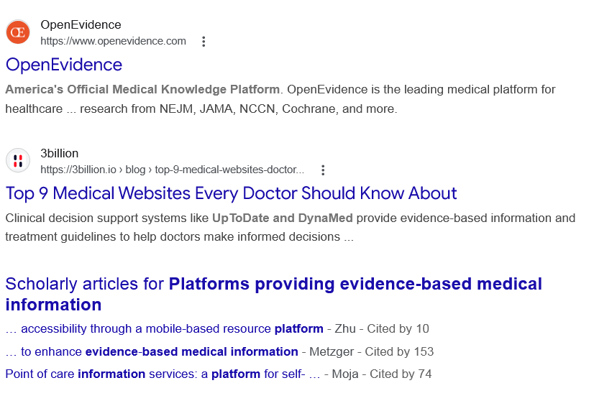
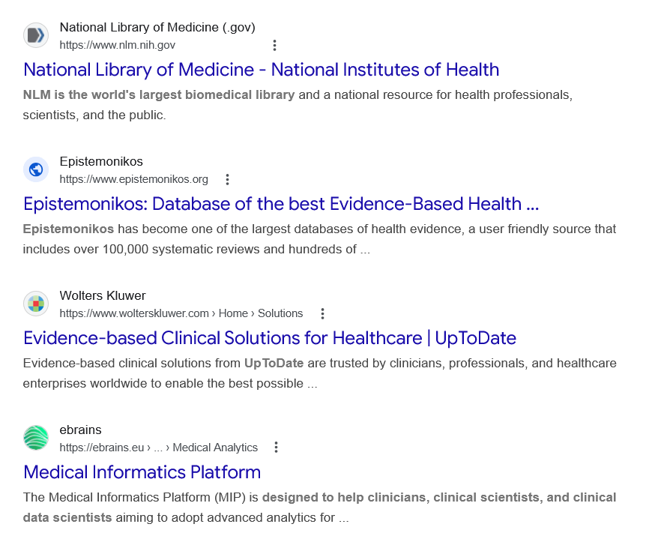
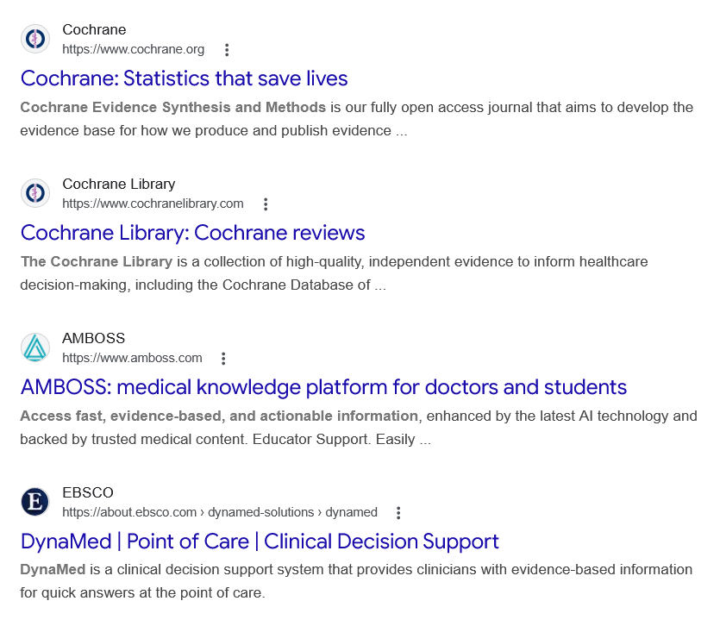
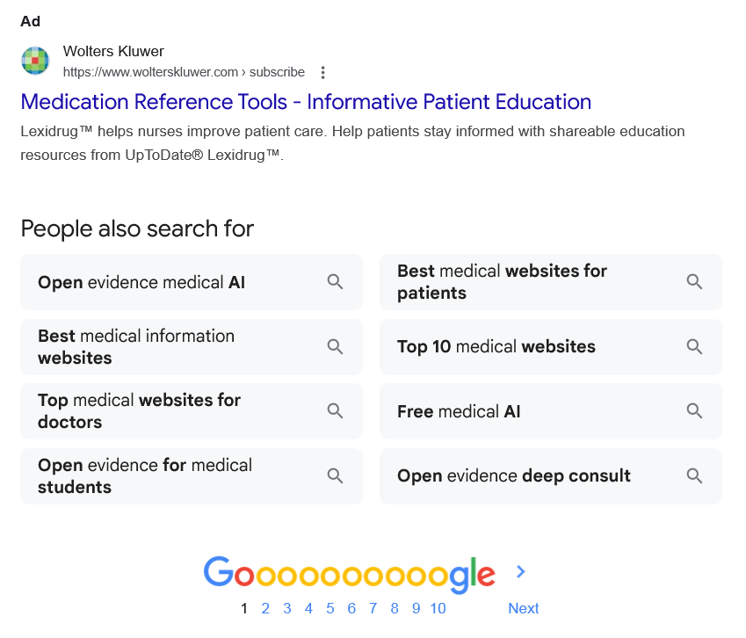

Web results

OpenEvidence

OpenEvidence
https://www.openevidence.com

OpenEvidence
https://www.openevidence.com
America's Official Medical Knowledge Platform. OpenEvidence is the leading medical platform for healthcare ... research from NEJM, JAMA, NCCN, Cochrane, and more.

Top 9 Medical Websites Every Doctor Should Know About

3billion
https://3billion.io › blog › top-9-medical-websites-doctor...

3billion
https://3billion.io › blog › top-9-medical-websites-doctor...
Clinical decision support systems like UpToDate and DynaMed provide evidence-based information and treatment guidelines to help doctors make informed decisions ...

Scholarly articles for Platforms providing evidence-based medical information
… accessibility through a mobile-based resource platform - ‎Zhu - Cited by 10
… to enhance evidence-based medical information - ‎Metzger - Cited by 153
Point of care information services: a platform for self- … - ‎Moja - Cited by 74

Web results

National Library of Medicine - National Institutes of Health

National Library of Medicine (.gov)
https://www.nlm.nih.gov

National Library of Medicine (.gov)
https://www.nlm.nih.gov
NLM is the world's largest biomedical library and a national resource for health professionals, scientists, and the public.

Epistemonikos: Database of the best Evidence-Based Health ...

Epistemonikos
https://www.epistemonikos.org

Epistemonikos
https://www.epistemonikos.org
Epistemonikos has become one of the largest databases of health evidence, a user friendly source that includes over 100,000 systematic reviews and hundreds of ...

Evidence-based Clinical Solutions for Healthcare | UpToDate

Wolters Kluwer
https://www.wolterskluwer.com › Home › Solutions

Wolters Kluwer
https://www.wolterskluwer.com › Home › Solutions
Evidence-based clinical solutions from UpToDate are trusted by clinicians, professionals, and healthcare enterprises worldwide to enable the best possible ...

Medical Informatics Platform

ebrains
https://ebrains.eu › ... › Medical Analytics

ebrains
https://ebrains.eu › ... › Medical Analytics
The Medical Informatics Platform (MIP) is designed to help clinicians, clinical scientists, and clinical data scientists aiming to adopt advanced analytics for ...

Cochrane: Statistics that save lives

Cochrane
https://www.cochrane.org

Cochrane
https://www.cochrane.org
Cochrane Evidence Synthesis and Methods is our fully open access journal that aims to develop the evidence base for how we produce and publish evidence ...

Cochrane Library: Cochrane reviews

Cochrane Library
https://www.cochranelibrary.com

Cochrane Library
https://www.cochranelibrary.com
The Cochrane Library is a collection of high-quality, independent evidence to inform healthcare decision-making, including the Cochrane Database of ...

AMBOSS: medical knowledge platform for doctors and students

AMBOSS
https://www.amboss.com

AMBOSS
https://www.amboss.com
Access fast, evidence-based, and actionable information, enhanced by the latest AI technology and backed by trusted medical content. Educator Support. Easily ...

DynaMed | Point of Care | Clinical Decision Support

EBSCO
https://about.ebsco.com › dynamed-solutions › dynamed

EBSCO
https://about.ebsco.com › dynamed-solutions › dynamed
DynaMed is a clinical decision support system that provides clinicians with evidence-based information for quick answers at the point of care.
Ad

Medication Reference Tools - Informative Patient Education

Wolters Kluwer
https://www.wolterskluwer.com › subscribe

Wolters Kluwer
https://www.wolterskluwer.com › subscribe

My Ad Centre
Lexidrug™ helps nurses improve patient care. Help patients stay informed with shareable education resources from UpToDate® Lexidrug™.
People also search for

Open evidence medical AI

Best medical information websites

Top medical websites for doctors

Open evidence for medical students

Best medical websites for patients

Top 10 medical websites

Free medical AI

Open evidence deep consult

Page navigation
 | 1 | 2 | 3 | 4 | 5 | 6 | 7 | 8 | 9 | 10 | Next

